‘Biggest ever’ brand push for Dark Knight Rises
Warner Bros UK has outlined what it describes as its “most extensive” promotional campaign to date as it looks to boost excitement for the release of its eagerly awaited movie, The Dark Knight Rises.
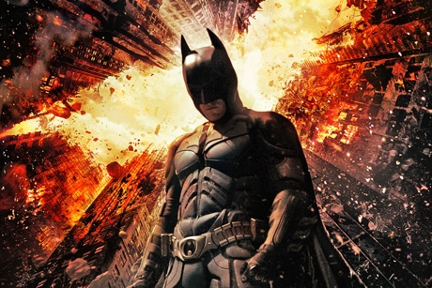
The film, which opens in UK cinemas next month (20 July), is being supported by promotional activity from the largest roster of brands the studio has ever assembled for a national release.
Pizza Hut Delivery and No Fear energy drink are the latest brands to sign up. Both will offer fans the chance to win prizes such as a Lamborghini and trips to LA And New York.
The promotions will run throughout the summer and will also include a national TV and print campaign as well as POS support in stores.
Other brands involved include French Connection UK, Nokia and Nissan (see below).
Danni Murray, director of media and marketing partnerships at Warner Bros UK, says the campaign for The Dark Knight Rises marks the latest iteration of the studio’s marketing strategy that aims engage fans throughout a film’s life cycle - cinema through to DVD and other format releases - an not just around its theatrical release.
He adds: “We’re fortunate to be working with a raft of big name brands and their agencies, with whom we have created a range of really innovative and impactful partnership campaigns that integrate perfectly with the rest of The Dark Knight Rises marketing activity.”
Brand activity is part of wider marketing push for the film that includes TV, outdoor and press adverts as well as an ongoing viral campaign that provides further detail on the film’s characters.

Promotional partnerships for The Dark Knight Rises:
Nissan UK - working with Warner Bros for the first time, the car marquee has built a campaign around its Juke model. It includes a major print campaign with artwork designed in collaboration with Gabriel Hardman - The Dark Knight Rises official storyboard artist.
Toshiba Electronics - the company is running a six week campaign to win tickets to the European premier of the movie in London.
Nokia - the only global partner on the UK roster is using the release to support the launch of its Lumia 900 smarthpone. The device will come packed with move content on a pre-installed handset. A further 900 limited edition versions of the handset will carry bespoke Dark Knight Rises branding.
French Connection UK - is selling limited edition TV shirts across 70 stores nationwide. All participating stores will feature props from the movie.
Mars - Consumers can purchase the first two films in the Dark Knight trilogy with family size pouches of their confectionery.
Armani - the Italian fashion house is supplying clothes for the actors to wear during various promotional events for the film.

