Film News: Win Tickets to The Dark Knight Rises Premier with Help From Toshiba
July 4, 2012
By Paul Metcalf
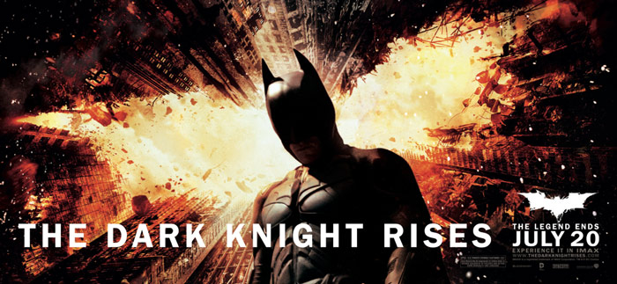
The Dark Knight series dramatically comes to an end this summer. To mark the occasion Toshiba has hidden 5 pairs of tickets around the internet.
You can follow a trail of clues to discover the locations of the tickets hidden around the web. Challenges range from finding hidden photos, unusual spots on Google Maps, decoding morse code messages and even secret websites. Once you’ve found the secret URL you type the address back into Toshiba UK’s Facebook page to enter the limited draw.
Each ticket is live for 72 hours and the last ticket closes on the 16th of July. Additional clues are also being posted on Toshiba UK’s Facebook page and Twitter account.
The Dark Knight Rises opens on the 20th of July. With the competition you could win tickets to the premier on 18th of July or a VIP screening on the 19th of July. The tickets are being given away in pairs so you can take a friend.
For the first clue visit here: https://www.facebook.com/toshibauk/app_326175354126621

