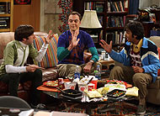
The Big Bang Theory
Scheduling Information

- TBBT is on every day of the week
- On average it is shown 7 times a day on E4 and E4+1. On Saturday and Sunday it is also shown on Channel 4.
- Its first airing is at 2.00pm. It’s last airing is at 12.35am.
- TBBT appears as part of E4’s stripped schedule format – programmes are scheduled at the same time every day. Audiences always know that at that time of day they can watch a specific programme.
- BBT is shown across three Channel 4 channels – E4, the time delay channel E4+1 and Channel 4. Over the course of one week the programme is aired over 80 times. This represents good value for money for the channel.
- Over the course of a week 28 different episodes are shown – each episode is shown about 4 times (twice on E4) – not necessarily in series order or from the same series. Series 4, 5, 6, 7 and 8 are currently being shown.
- The Tuesday, Thursday and Friday evening slots (8.30pm and 9.30pm) are for the latest series. TBBT is currently on series 8. Two episodes from the current series are shown each week.

TBBT is part of a stranded programme of US comedy – programmes of a similar theme and style are programmed and advertised together –
In its regular weekday slot TBBT is hammocked between

How I Met Your Mother
Comedy about five friends living in New York, which takes place in a continual flashback narrated by Future Ted as he tells the story of his love life.

Hollyoaks
Long running Soap opera which revolves around the lives of a group of teenagers

These programmes have a very similar target audience to TBBT. HIMYM is very similar in its format as it deals with friends who live and work near each other and have romantic entanglements.

On Wednesday, Friday, Saturday and Sunday evening TBBT is on before and after the feature length movie. Channel 4 know TBBT is popular and its viewers will be happy to watch one-off episodes at any time.
TBBT Scheduling

TBBT scheduling questions
- How many times can you watch TBBT during one week?
- On which channels can you watch TBBT?
- How many different episodes of the TBBT are shown each week?
- How many episodes of the latest series are shown each week?
- Why do you think the latest series is shown in the 8.30pm and 9.30pm slots?
- Between which programmes is TBBT hammocked?
- Why do you think TBBT is positioned between these programmes?
- Why is a movie hammocked between episodes of TBBT on Weds, Fri, Sat and Sun?
- What is a stripped schedule? Explain how TBBT fits into a stripped schedule
- What is a stranded programme? Explain how TBBT fits into a stranded programme format.

Exam question [15 marks]

Discuss in detail how and why one comedy programme was scheduled on one or more channels.

Mark Scheme

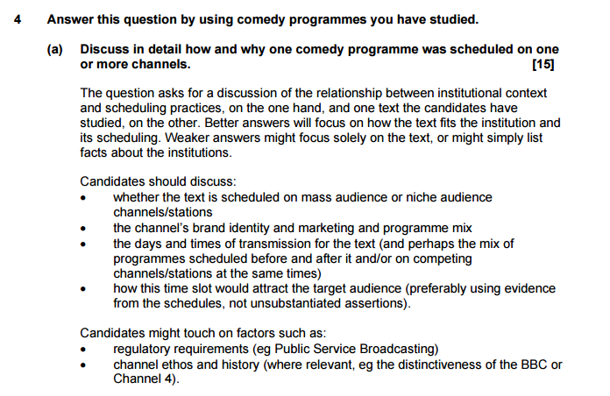

You should refer to
- the channel’s brand identity, ethos and target audience remit
- the way TBBT is scheduled (days, times, frequency, positioning)
- how the time slots attract the target audience

