Nissan Releases Batman Inspired Nissan Juke
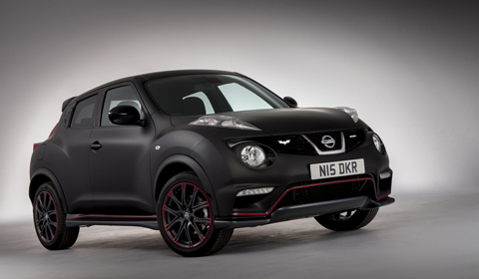
With the release of the latest Christopher Nolan blockbuster in the Batman series, The Dark Knight Rises, Nissan has created a special one-off Nissan Juke Batman Edition. In conjunction with the release of the film on Blu-Ray in the UK, Nissan is giving the car away to the winner of their Built to Thrill campaign.
Batman styling touches include matte black exterior paint in addition to scattered Batman logo motifs spaced around the car. The most obvious of which can be found above the Juke logo on the rear, in the front grill and on the interior glove compartment.
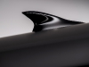
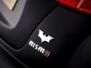
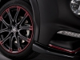
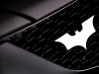
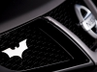
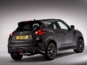
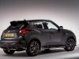

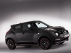Additional nods to the film franchise include a trick interior lighting system that projects the Batman logo onto the headliner. Red garnishments accent the exterior and rims. Instead of the stock antenna, a shark-fin shaped radio antenna is affixed in its place.
A suede interior stitched with Batman logos completes the package. Engine and drivetrain remain the same as the stock Juke, with a 1.6 liter turbocharged inline-four producing 197hp.

