LEGO ‘Let’s Build’ Television advert

Screen Shot | Camera Shot – What shot type – what can we see in the frame? | Explain how the mise en scene – CLAMPS - is used to  represent gender.
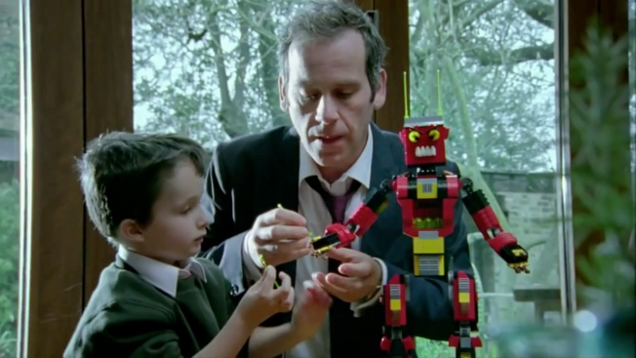

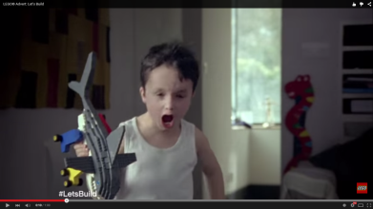

Screen Shot | Camera Shot – What shot type – what are we focusing on? | Explain how the mise en scene – CLAMPS - is used to  represent the woman and her family
