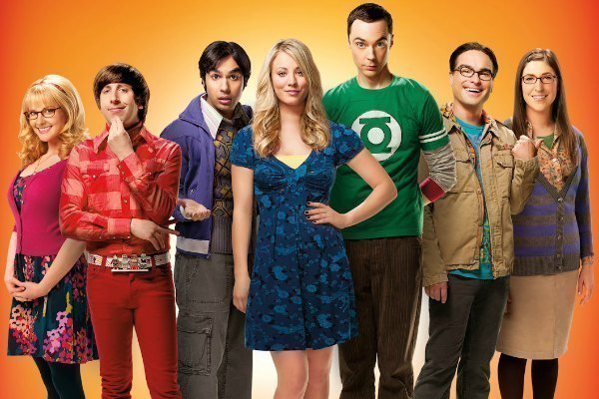
CAST

(From Left)

Bernadette
Dr.Bernadette Rostenkowski-Wolowitz is originally a waitress and coworker of Penny's at the Cheesecake Factory, which pays the way for her graduate studies in microbiology

Howard
Howard Wolowitz is an aerospace engineer with a Masters in Engineering who often hangs out at Leonard and Sheldon's apartment. Unlike Sheldon, Leonard, and Raj, Howard has no doctorate, and often gets disparaged as a result, especially by Sheldon.

Raj
Dr. Rajesh “Raj" Koothrappali is Howard Wolowitz's best friend, and yet another genius of the group; his name is usually shortened to "Raj". He is originally from New Delhi, India, and he works in the Physics department at Caltech, where his area of expertise is particle astrophysics

Penny
Penny is Leonard and Sheldon's neighbor across the hallway. She was a waitress and occasional bartender at the local Cheesecake Factory until season 7 and is an aspiring actress

Sheldon
Dr. Sheldon Lee Cooper is a theoretical physicist, possessing a Bachelor of Science, Master of Science, PhD, an ScD, and an IQ of 187

Leonard
Dr. Leonard Hofstadter is an experimental physicist with an IQ of 173

Amy
Dr Amy Farrah Fowler is a neuroscientist and Sheldon's love interest in the series.

