Ultimate Batphone created by Nokia as Dark Knight Rises hype builds up

By Etan Smallman Tuesday 17 Jul 2012 6:10 pm Tech
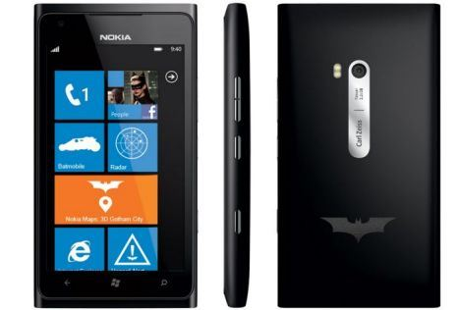Nokia have created a phone to fulfil all of Batman’s needs (Picture: Nokia)
The waterproof Nokia Lumia can detect poison, warn against potential obstacles that threaten to stand in your way, disguise your voice and be controlled remotely.
It may sound like the perfect device for the Caped Crusader but the technology is not confined to fiction – experts are trying to make it part of your smartphone.
Any user can already download apps to distort their voice during calls but Nokia is working to up the ante.
It hopes to create what would effectively be an artificial nose by using a microchip to sniff out substances, such as polluted air. As well as 3D radar, the mobile giant’s research arm in Cambridge is also testing an electronic skin made from pliable ‘bio-electronics’ that can access a phone using sensors placed on your body.
Rival Apple last year launched its Siri service, allowing iPhone users to tell their device what to do by speaking to it.
However, ‘gesture recognition’ could be a reality in the next year, meaning users will be able to control their handset simply by waving their finger in front of it.
Jem Davies, of chip designer ARM, added that, within five years, disposable sensors could be integrated into clothing, while smartphones could replace the keys to your front door.
Google is not planning on being left behind, with its augmented-reality Google Glass – which will project information on to a pair of glasses – in development.

