Identify the Camera Shot – write the correct term in the box
big close up close up extreme close up extreme long shot high angle long shot low angle
point of view medium shot medium long shot
 | Description | Camera Shot Term | Effect on audience
 | The camera is very close to the subject. Some parts of the subject’s face would be out of the frame. |  | The audience feels very close and intimate to the subject. The way the shot is cropped can be used to create an artistic effect.
 | You can see the head and shoulders of the subject. |  | The audience feels close to the subject but can see some of the background which helps to put the subject in a setting/context.
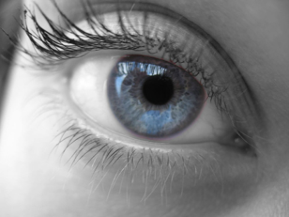 | This is the closest the camera can get to a subject. You can see the subject’s eyes and nose, for example, but not their face |  | The audience can only focus on one small part of the subject. It is often used to indicate something important. Sometimes - it can make the audience feel trapped or claustrophobic. It can smaller object seem large.
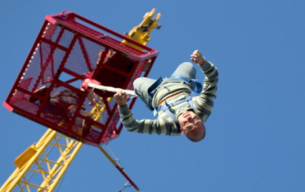 | The camera is below the subject looking up at it. |  | The audience is made to feel small and weak. They can sometimes feel threatened. Sometimes it’s just a fun angle
 | You can see the subject’s whole body. The camera is far away. |  | The audience feels quite distant from the subject as if they are watching/observing from far away. It allows the audience to see the subject and some of the background
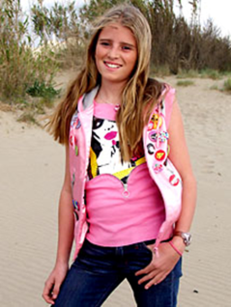 | You can see the head, shoulders and just above or below the knees of the subject. |  | The audience is at a distance from the subject but we can still see features. It allows you to see a
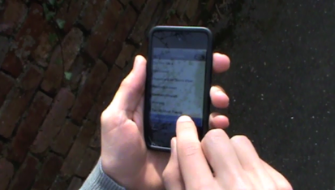 | We feel as if the camera is looking at the subject through our own eyes. |  | The audience is made to feel like a character in the movie. It is very intimate as we become the eyes of the character
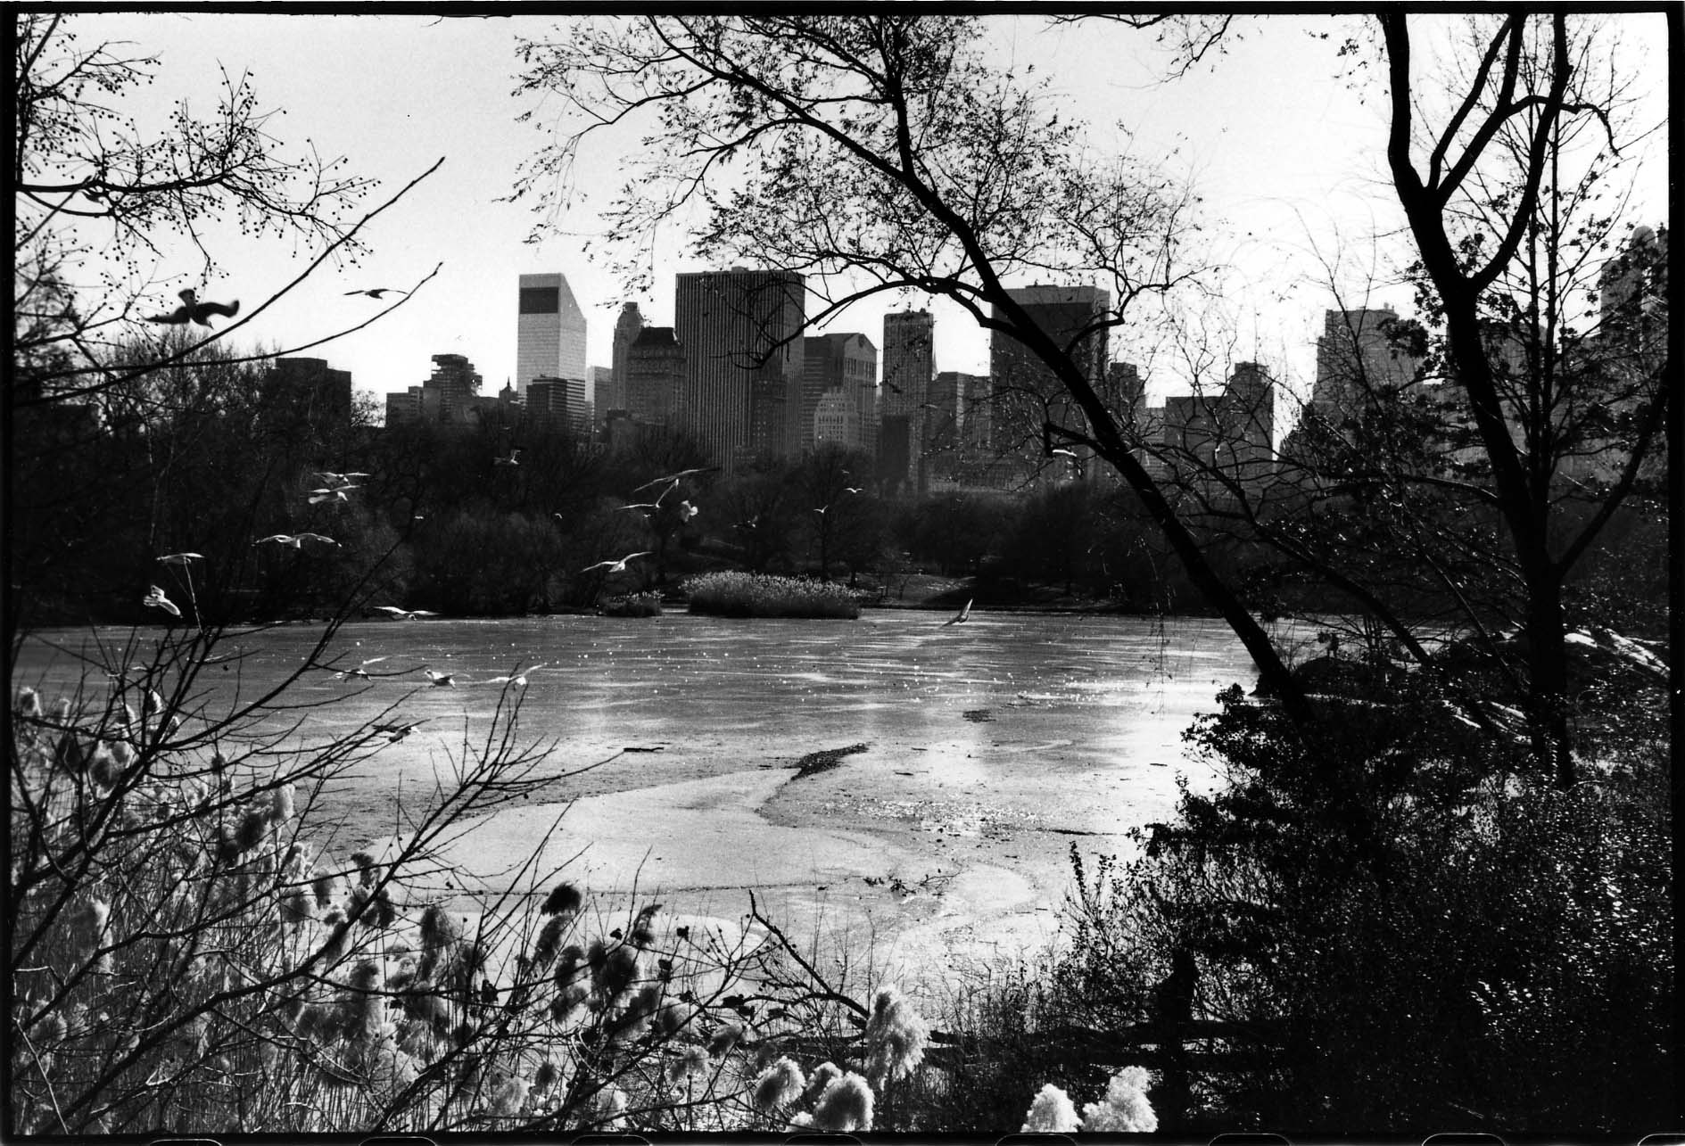 | The camera is very far away from the subject. There is a lot in the frame. |  | This shot helps us to see everything in the frame. We feel very distant and separate from the subject. It is often used at the beginning of a sequence to let us know where the scene is set.
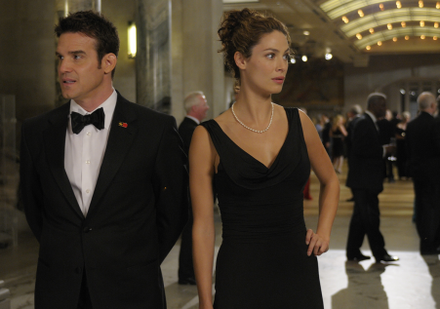 | The camera shows two people in the same frame. |  | This shots helps the audience to see the relationship between two characters.
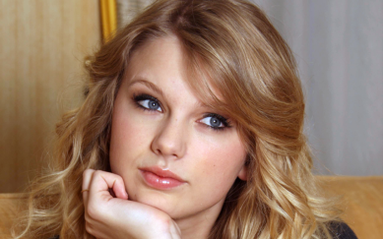 | The camera is close to the subject. You can see the subject’s whole face. |  | The audience feels close and intimate with the subject. It helps us focus on a person’s thoughts and feelings or to focus on something important.
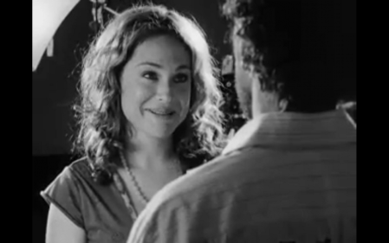 | The camera is positioned over the shoulder of a character in the scene |  | This shot is often used in dialogue shots so that we can see both characters but can focus on the face of one of them. Sometimes we feel as if we are in the scene with the characters.
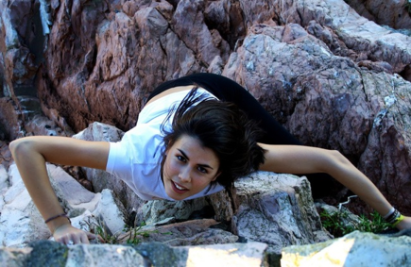 | The camera is above the subject looking down on it |  | The audience is made to feel more powerful than the subject.
 | The camera appears to be in the sky looking directly down on the subject |  | This is a dramatic shot that puts the audience is a very powerful position making the subject seem small and insignificant. It can also be used to show the scale of a the subject (how big or small it is)

